AMERICAN CAR CRAFT
18701 Old Shady Hill Rd. Spring Hill, Fl. 34610
Phone: 727 857-1151 Fax: 727 856-0273
www.americancarcraft.com

05-06 MUSTANG STAINLESS SPEAKER GRILLE OVERLAYS
PART#MGSG505 or #MGSG506 patent pending

INSTALLATION INSTRUCTIONS

PARTS INCLUDED:
___ 2-Stainless Speaker Grilles
___ 2-Strips ¼” Chrome Molding
___ 2-Tubes of Adhesive Promoter
___ 2-Packs of Adhesive Promoter
___ 2-5/8” Chrome Molding Strips
___ 1-Test Kit

Your new covers come to you with a protective liner. Do not remove liner until installation is complete.

- Detach the door speaker grille surround from the speaker housing. It should just simply pull off. You will notice that there are six areas to the inside of this grille surround. These six areas will need to be filed flush so that you create a nice continuous circle inside of the surround ring. We have found this easy to accomplish using a common rasp file. These areas are small and should be able to be filed quickly. SEE EXAMPLE:
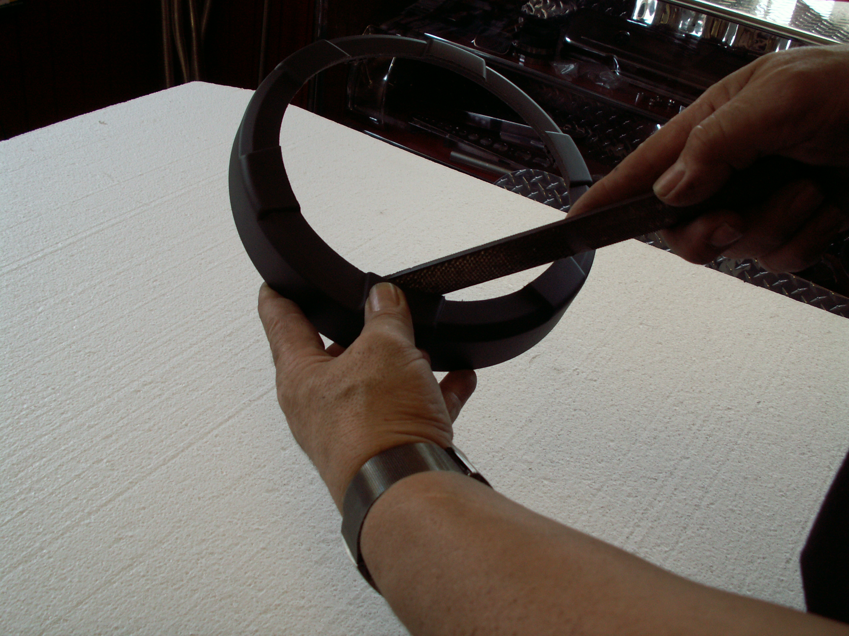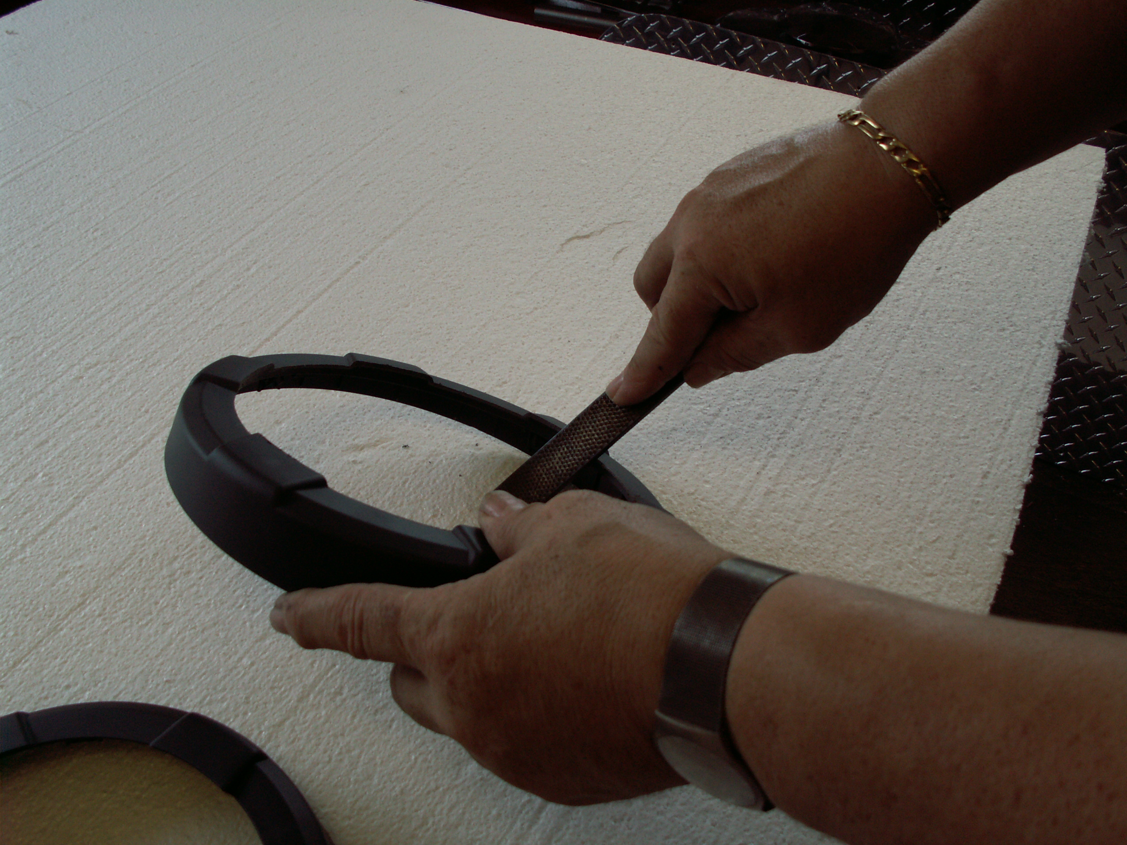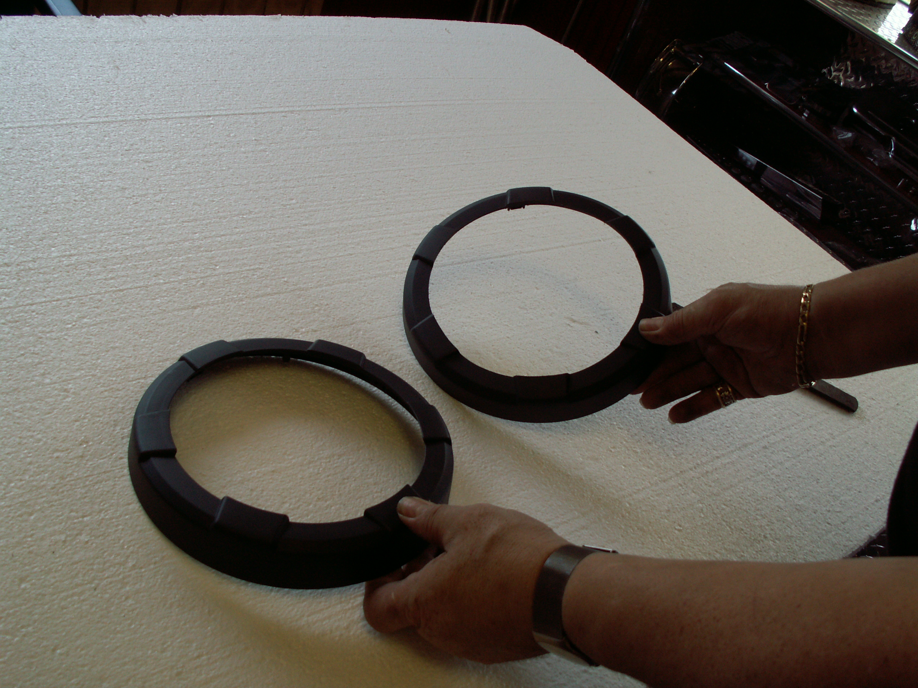

- With the speaker exposed on the door you will notice that there is a beveled edge on the speaker grille itself. This bevel is where the speaker trim is to be mounted. Scrub this area first with household rubbing alcohol to prepare surface then swipe with the adhesive promoter provided.

- You have been provided with a narrow length of chrome trim. Peel a small length of red release liner from one end of the trim and place the end directly to the bevel making sure that you will create the seam at the bottom of the speaker. Work your way around to the start point and create a nice tight butt seam. After this has been completed simply snap the modified surround back into place to lock the trim in position. SEE EXAMPLES:
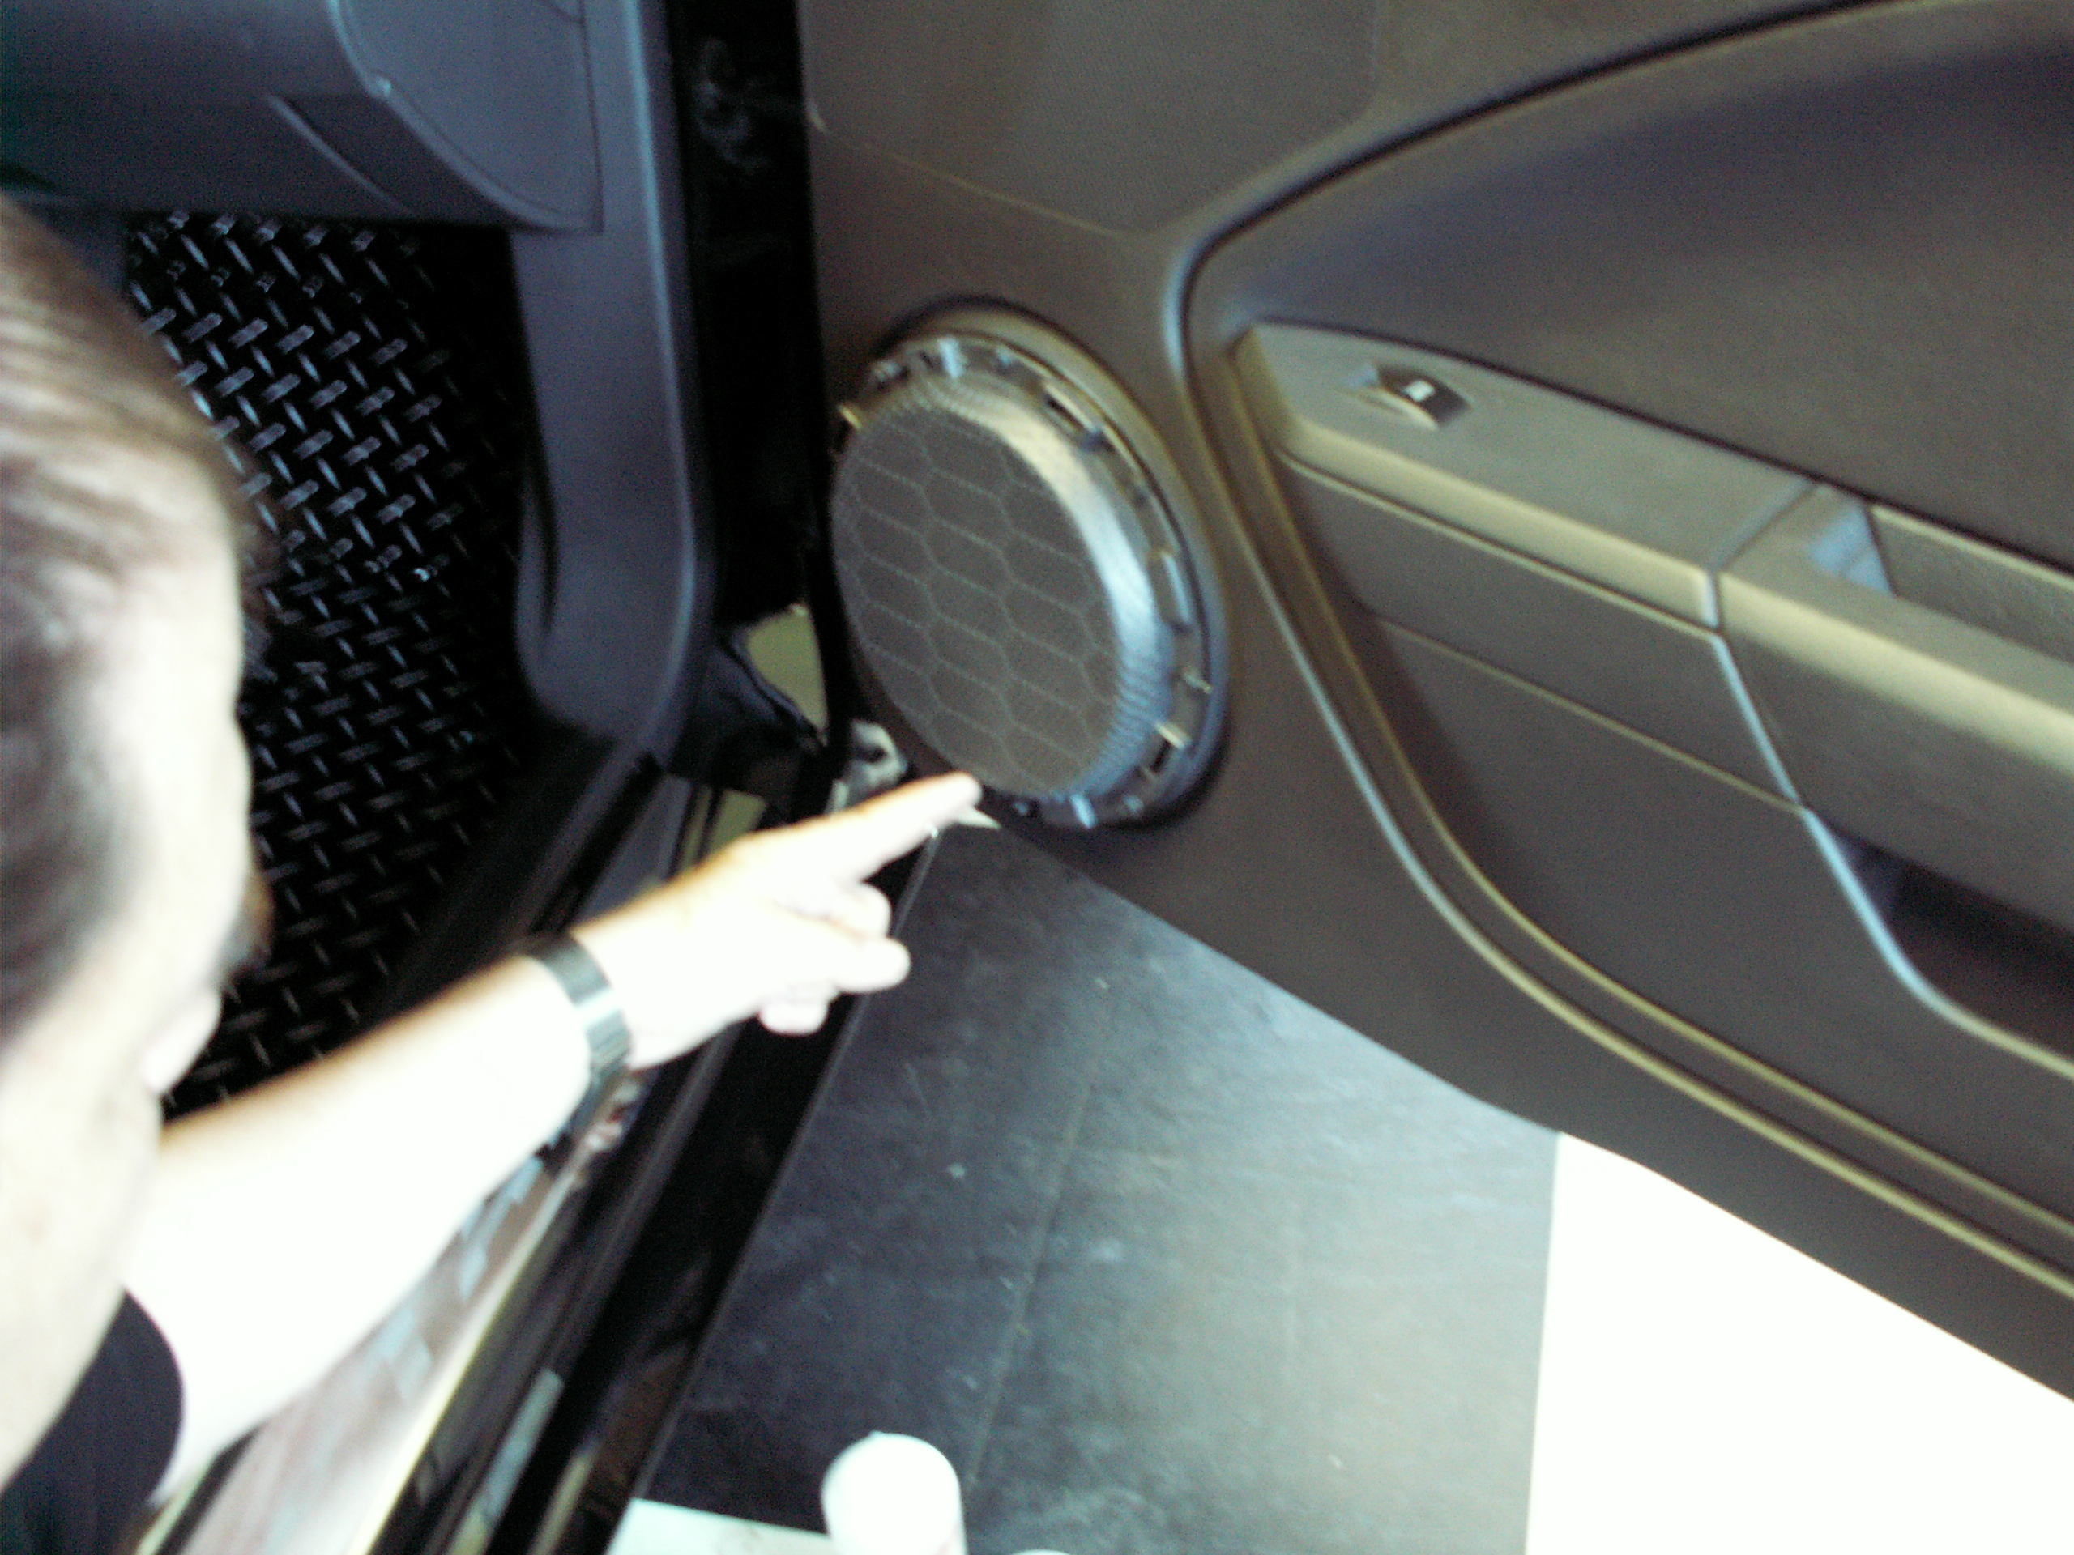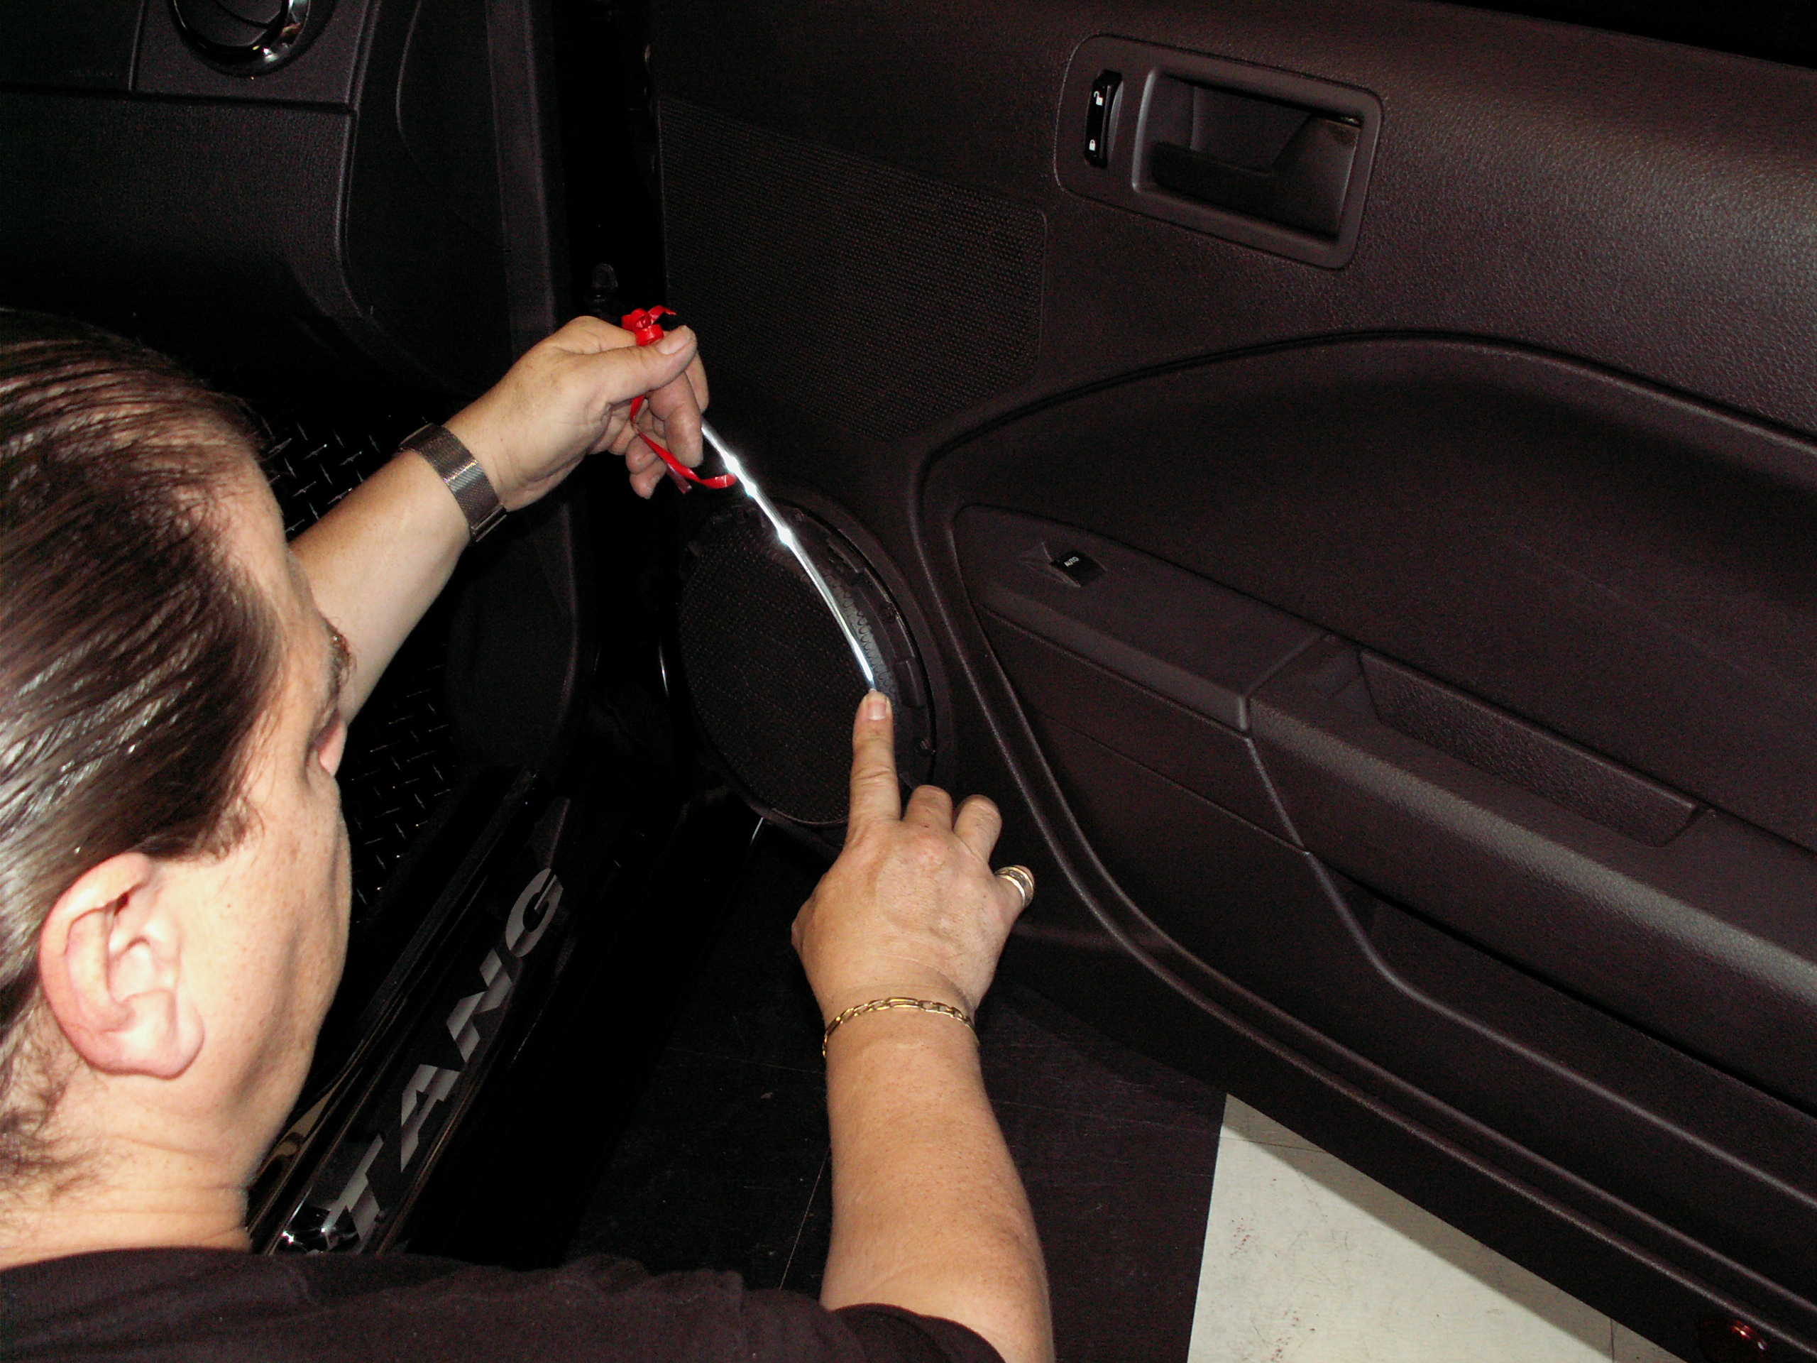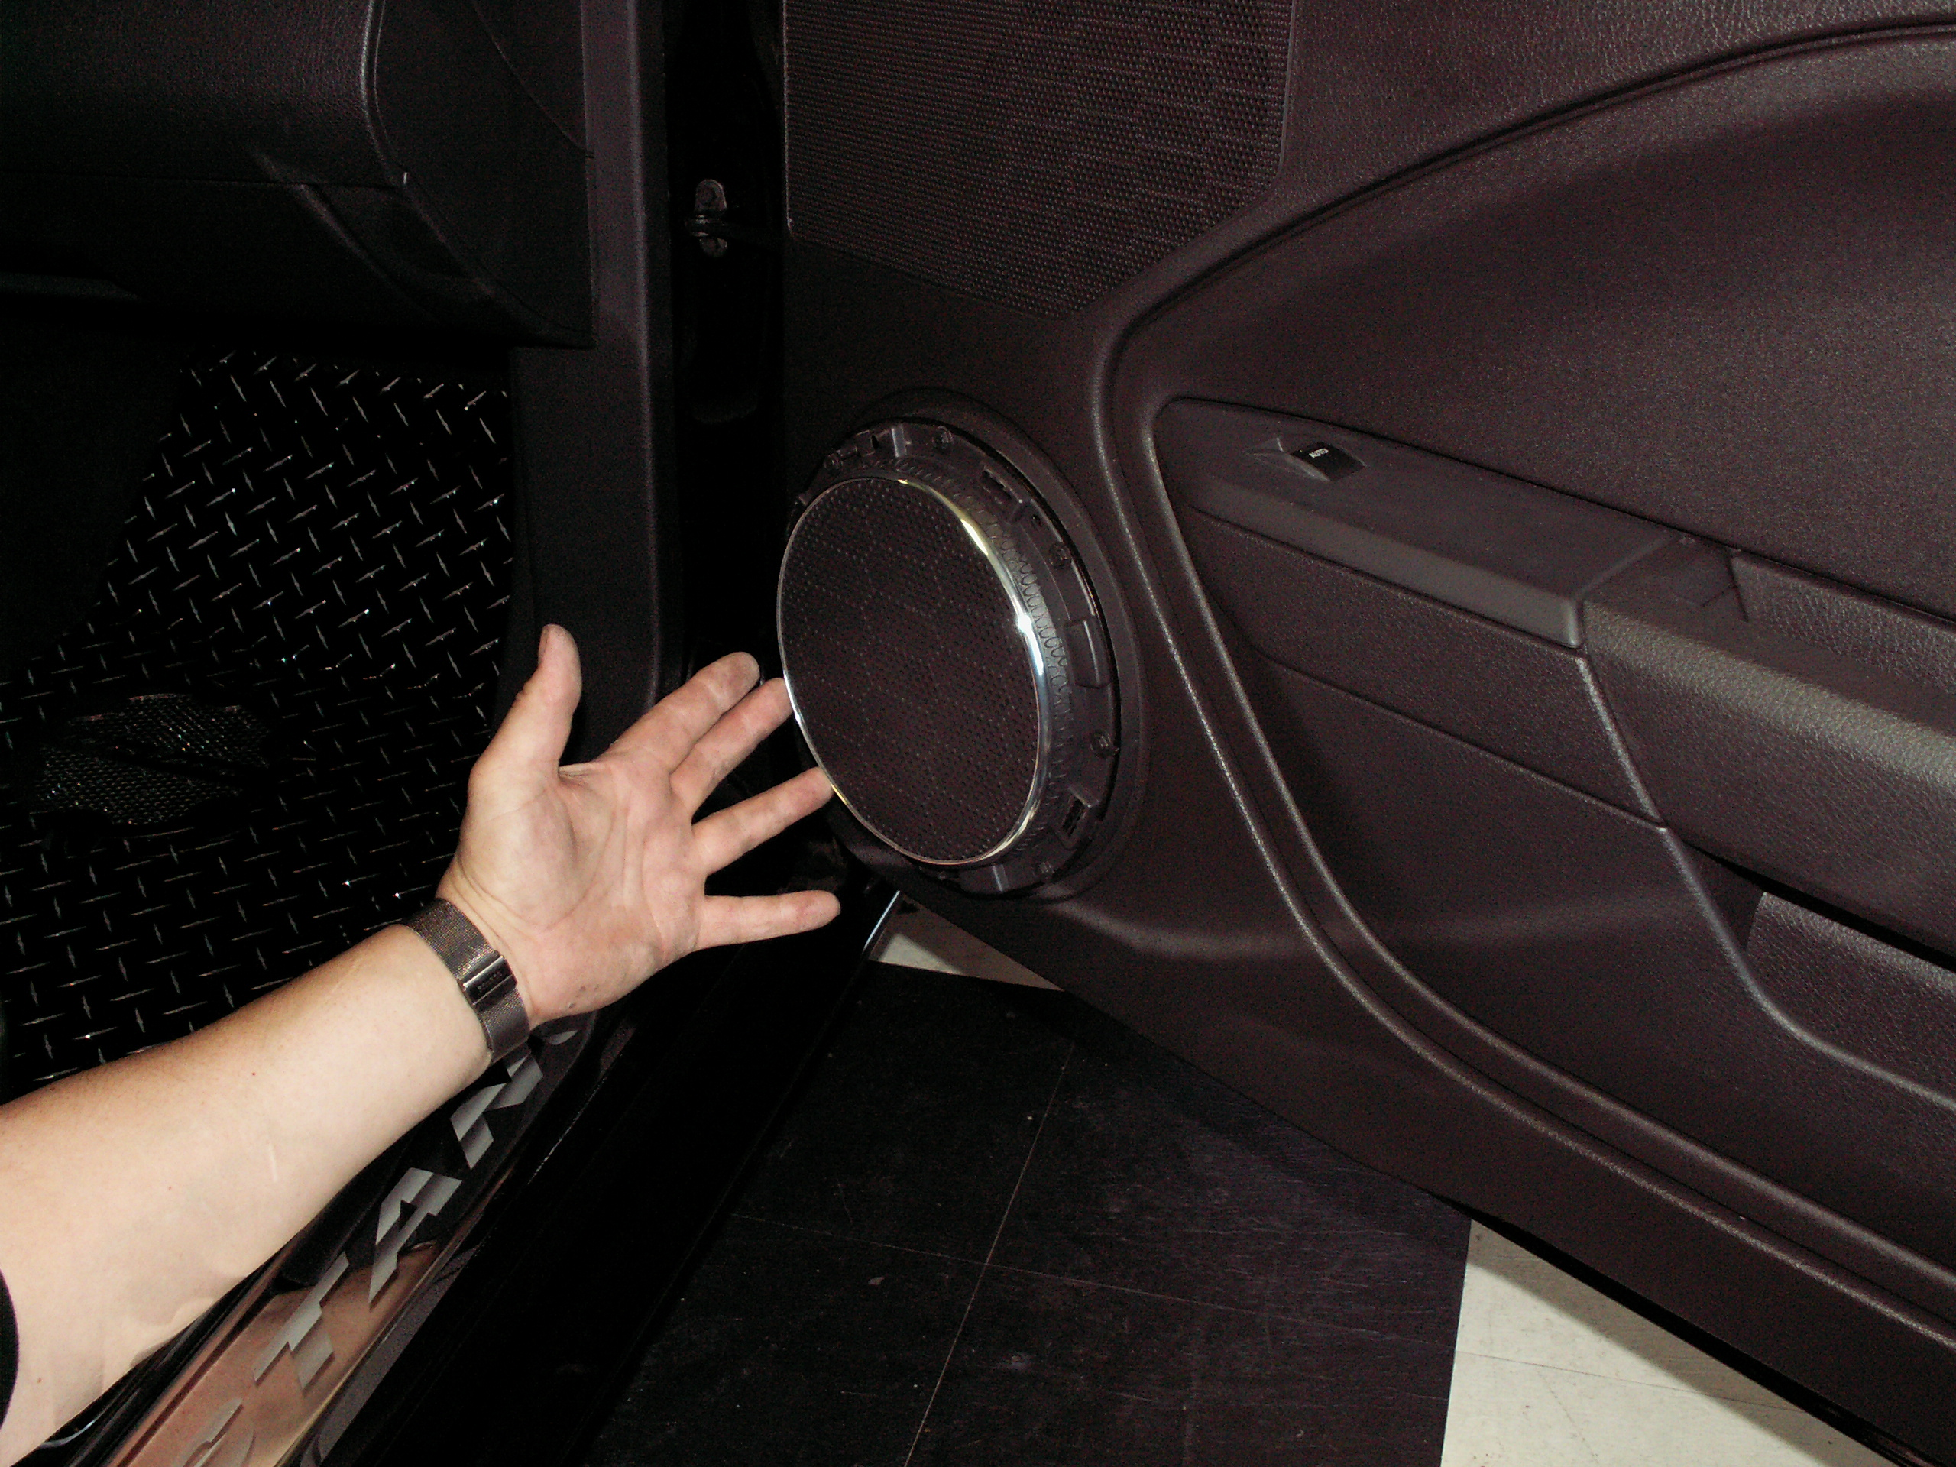

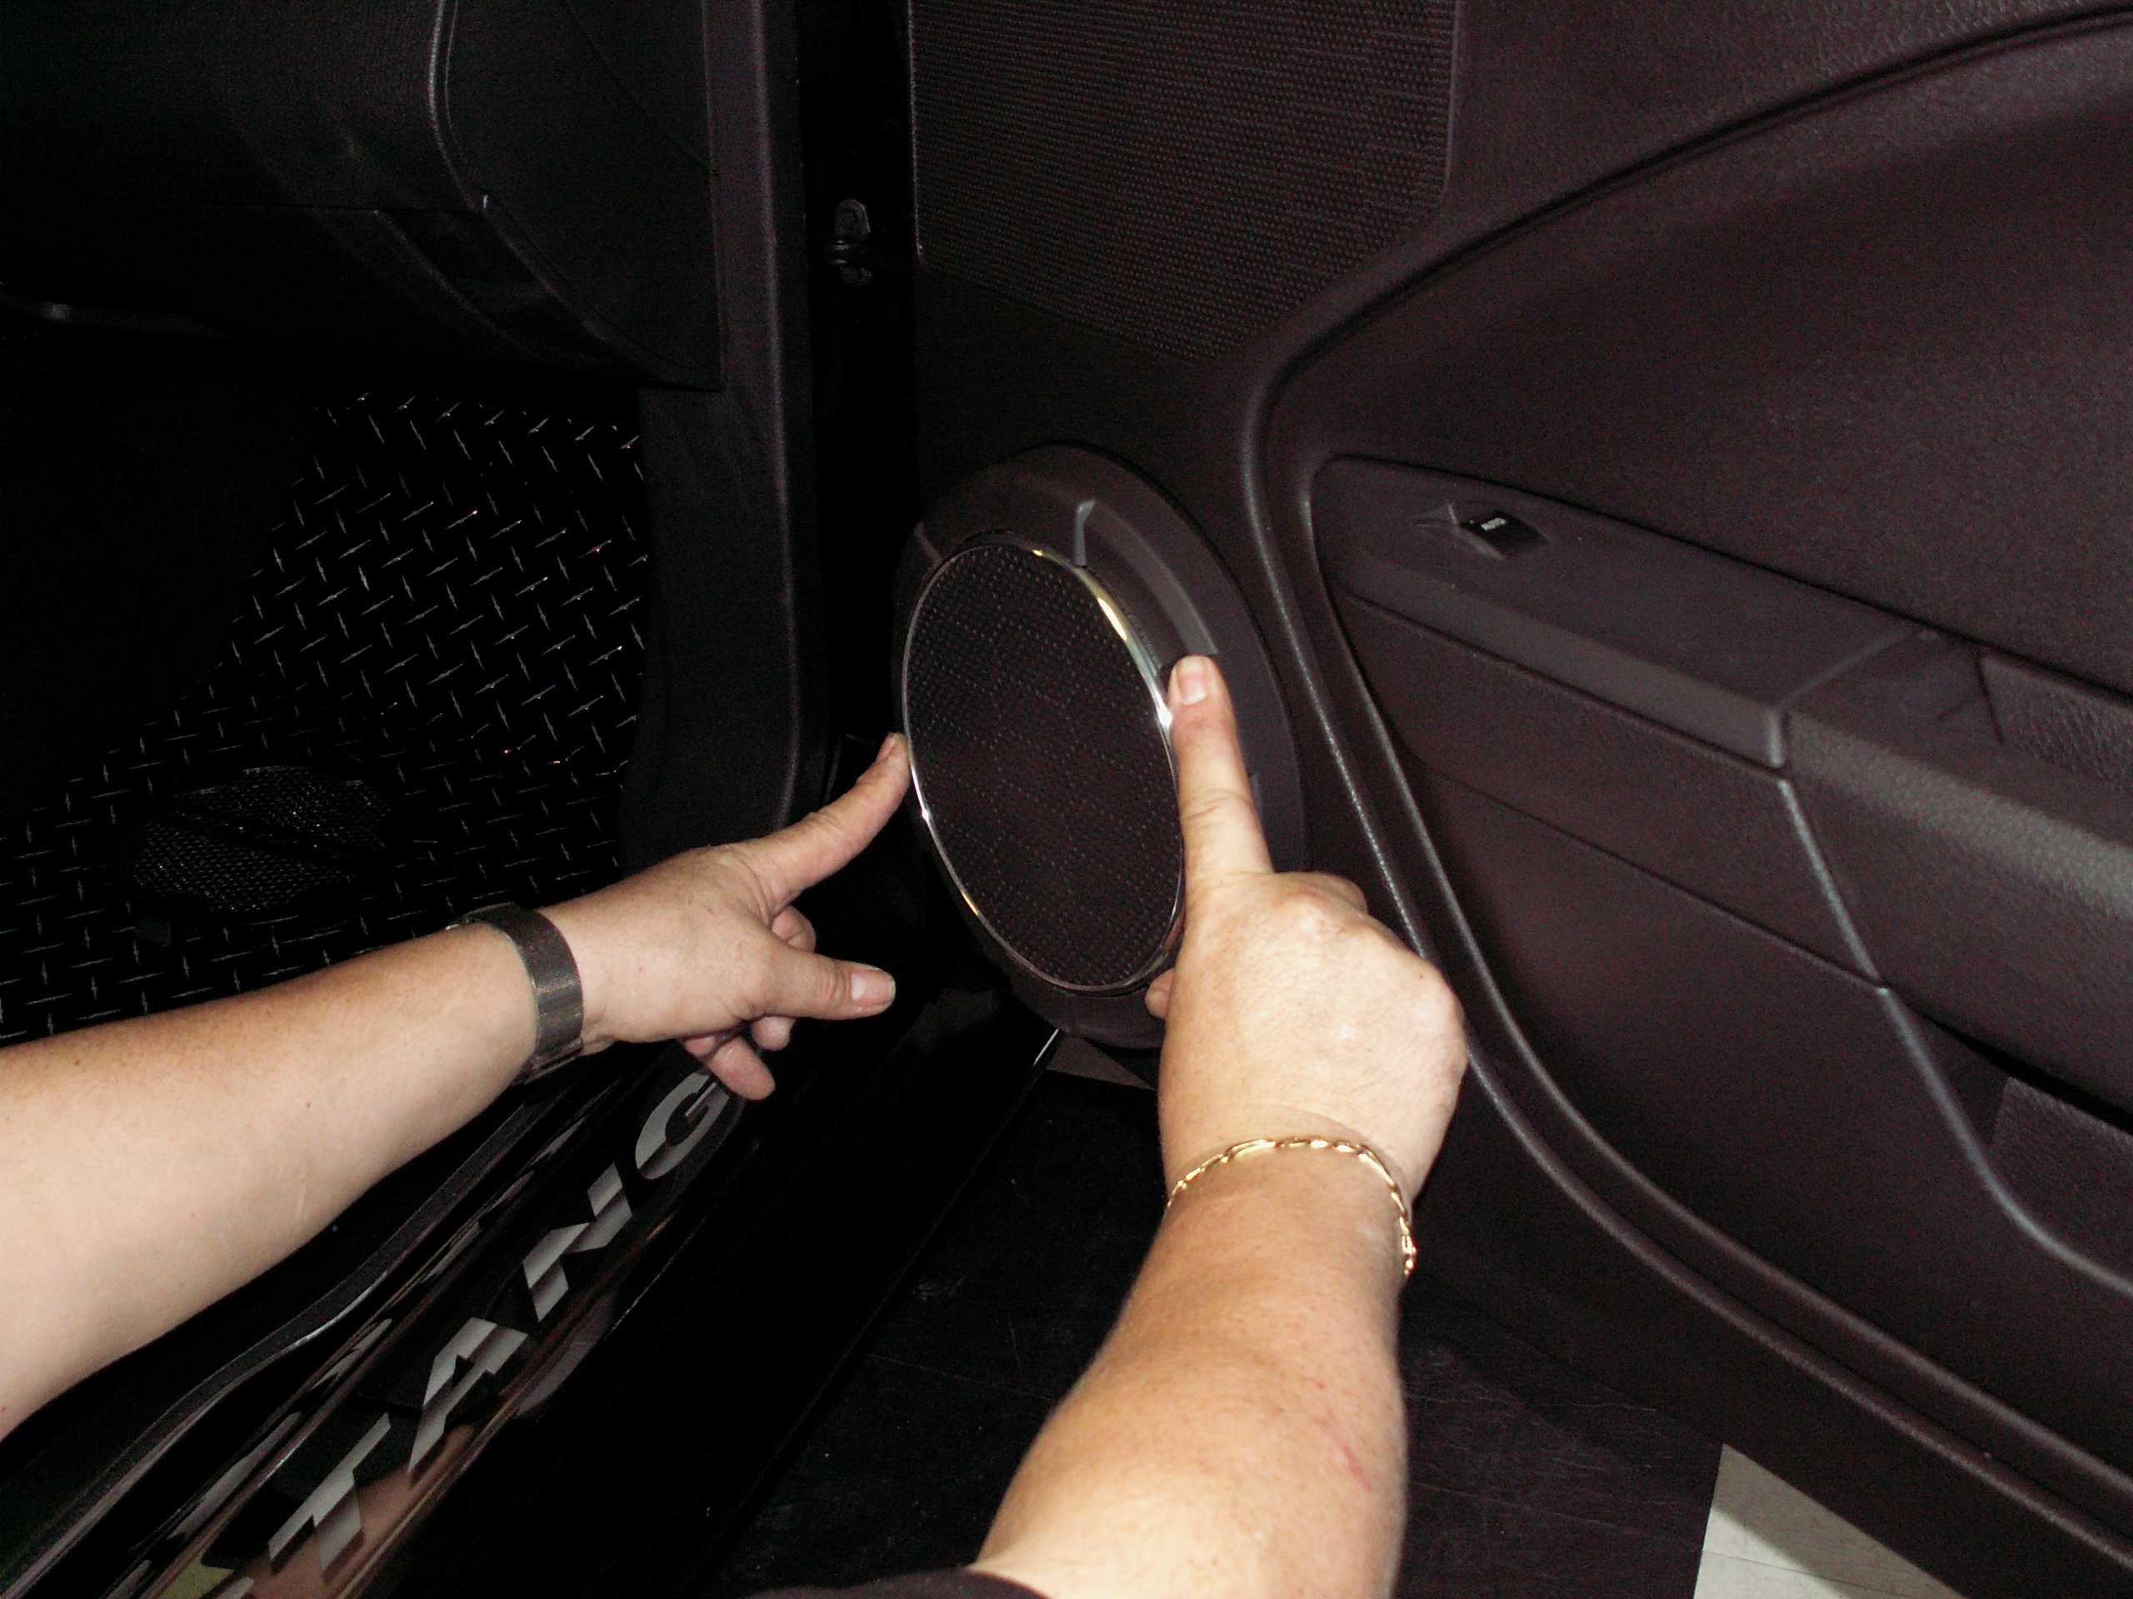

- Scrub the six modified tabs and the outer rim of the grille surround cover you just installed with household rubbing alcohol to prepare the surface then with the adhesive promoter pad provided. You have been provided with a wider length of chrome trim. Starting at the very bottom of the outer rim peel a small length of release liner from the trim and firmly press it directly against the speaker surround and as tight to the door panel as possible. Work your way to the start point and snip the excess trim into a nice tight butt seam. If done correctly it should close the gap between the factory grille surround and the door panel creating a nice looking finish.
SEE EXAMPLE: 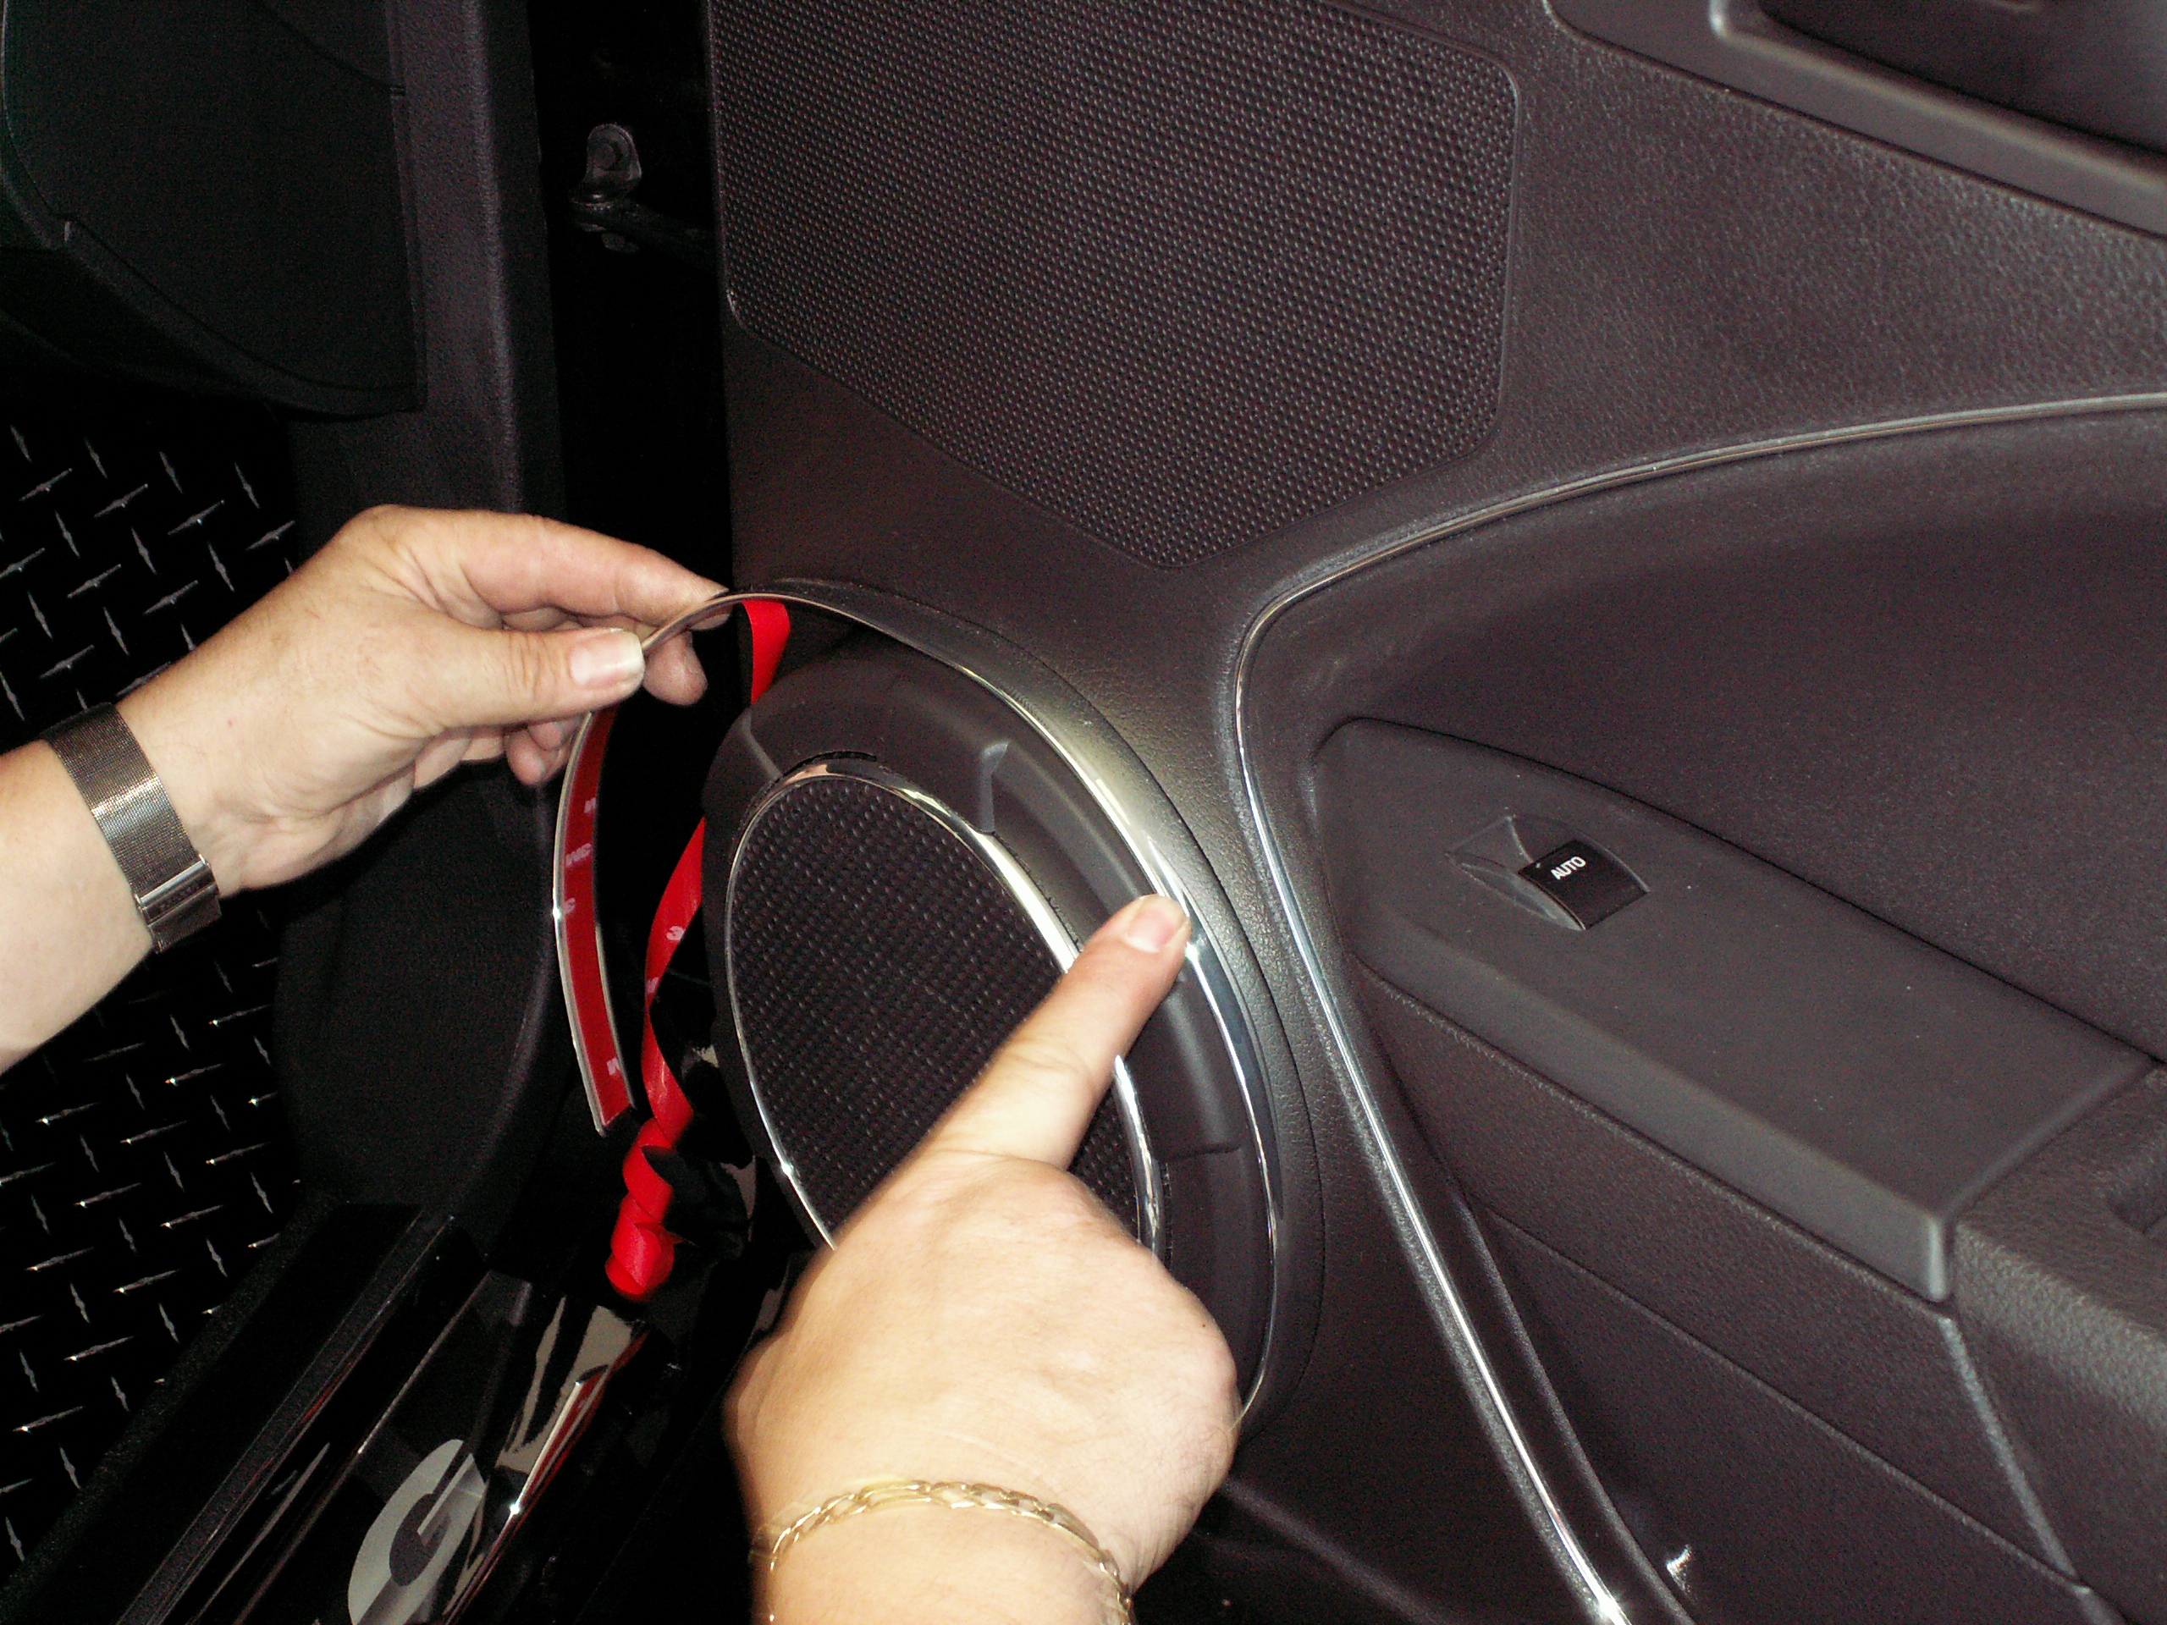

- With the front surface tabs properly prepared simply remove the red release liner from the back of the new stainless grille overlay and carefully line up the six overlay tabs with the grille surround tabs and firmly press the new cover into position. Remove the protective liner.

SEE EXAMPLES: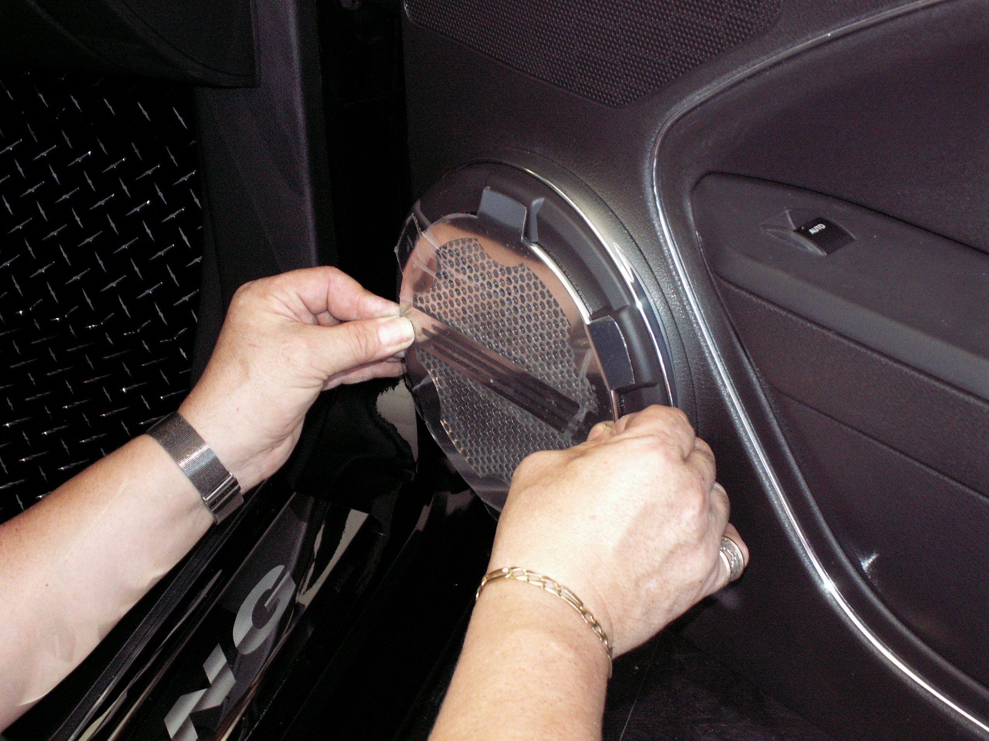 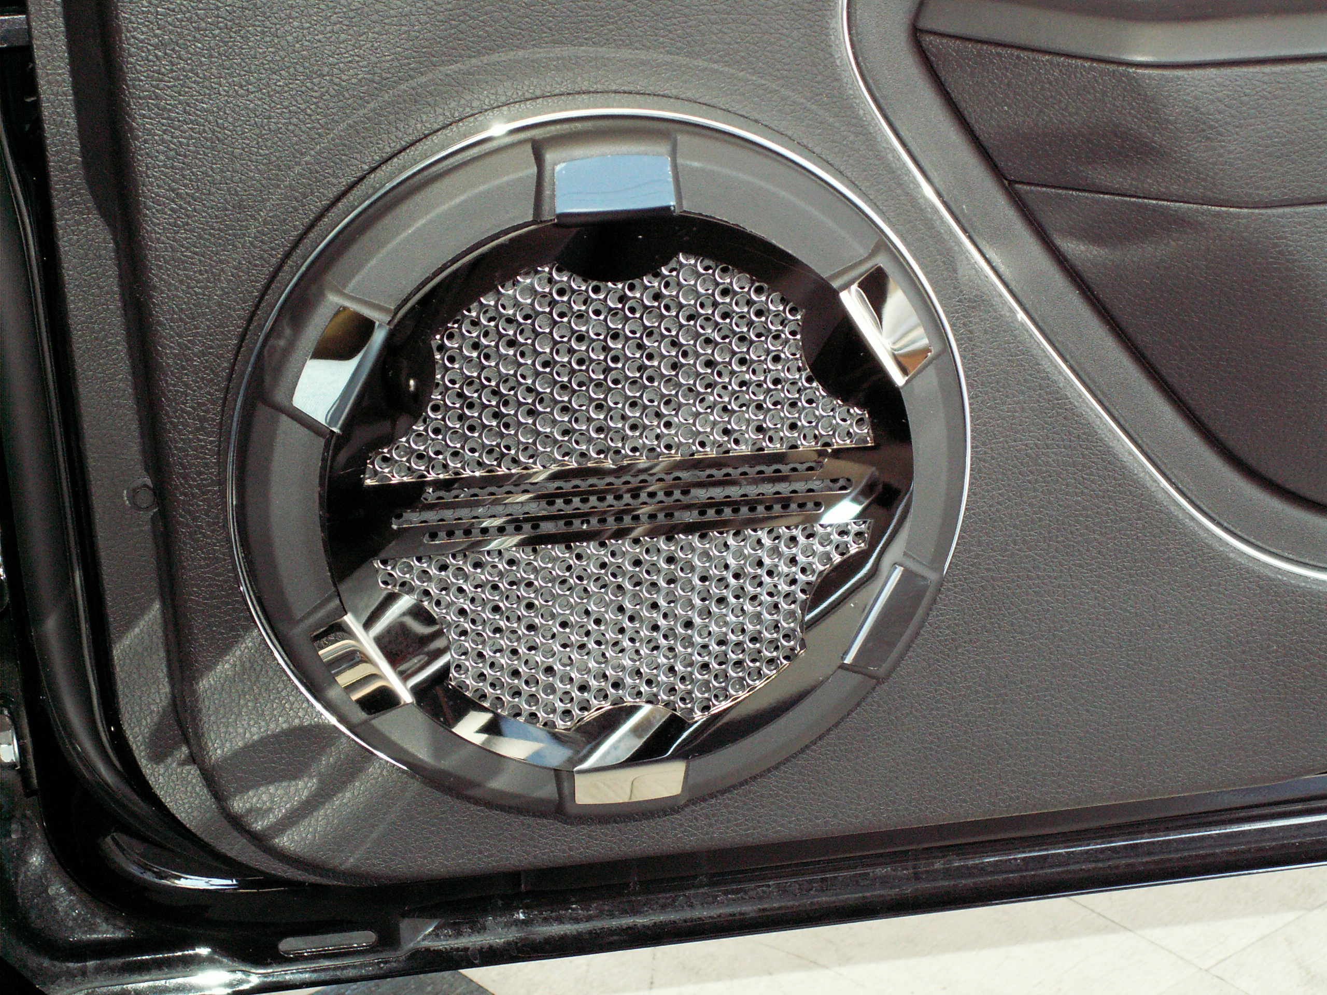

- Repeat steps for the opposite side.

If any questions occur during installation, please contact American Car Craft at 727 857-1151.
Thank you and enjoy your new panel.

Note: Care must be taken when cleaning your panel. It is a good idea to lightly dust your panel with a clean soft cloth first in order to prevent any particles from scratching it. Then wipe (using a new clean soft cloth) with a good quality streak free glass cleaner.

